Asynchronous Transmission
- 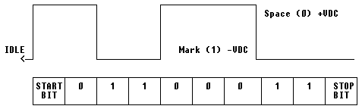
- Asynchronous transmission is also known as start-stop mode or character mode.
- Each character is sent as an independent unit of data that may be transmitted and received independently. However Data may also be transmitted as a continuous stream of characters.
- Asynchronous data characters normally contain 8 data bits (including the parity bit) plus a start bit and at least 1 stop bit, giving a total of 10 bits.
- Data can be transmitted in blocks of characters known as transmission blocks.
- Asynchronous transmission is only really suitable for relatively low data rates (up to 3 Kbits).
- Many of the bits transmitted in each block are control bits, giving a high proportion of overhead.
- It is used mainly for applications where character data is generated at irregular intervals (e.g. user input from a keyboard).

Synchronous Transmission
- With synchronous transmission, the receiver's clock is synchronized with the transmitter's clock.
- Data is transmitted in a continuous stream, and the arrival time of each can be predicted by the receiver.
- This is achieved either by using a separate timing circuit, or by embedding the timing information in the signal itself. The can be achieved using bi-phase encoding (e.g. Manchester encoding).
- To keep the transmitter and receiver synchronized, data is transmitted in frames. Frame includes special instruction and control bit for synchronization
- Synchronous transmission uses no start and stop bits but instead synchronises transmission speeds at both the receiving and sending end of the transmission using clock signals built into each component.
- Due to there being no start and stop bits the data transfer rate is quicker

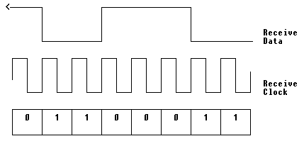
- For large blocks of data, synchronous transmission is far more efficient than asynchronous transmission, requiring far less overhead.
- The accuracy of the timing information allows much higher data rates.

